**PROJECT REPORT**

**I.INDRODUCTION**

**TITLE**: **Analyzing the Performance and Efficiency of Radisson Hotels Using Data Visualization Techniques**

1. **Introduction:**

The hospitality industry is highly competitive, and hotels need to constantly analyze their performance and efficiency to stay ahead. Radisson Hotels, a global hotel brand, is no exception.

In this project, we aim to analyze the performance and efficiency of Radisson Hotels using data visualization techniques. The project will involve collecting data from various sources, cleaning and processing the data, and using data visualization tools to gain insights into the performance and efficiency of Radisson Hotels.

**2.Objectives: The main objectives of this project are:**

To analyze the performance of Radisson Hotels in terms of key performance indicators (KPIs) such as revenue, occupancy rate, average daily rate (ADR), and revenue per available room (RevPAR).

To assess the efficiency of Radisson Hotels by analyzing data related to operational metrics, such as labor costs, guest satisfaction scores, and energy consumption.

To use data visualization techniques to visually represent the findings and insights derived from the data analysis, including charts, graphs, and other visualizations.

1. **Methodology: The project will follow the following methodology:**

Data Collection: Data will be collected from various sources, including internal hotel data such as financial statements, operational reports, and guest satisfaction surveys, as well as external data such as industry benchmarks and market data.

Data Cleaning and Processing: The collected data will be cleaned and processed to remove any inconsistencies, errors, or missing values. Data will be organized and transformed into a suitable format for analysis

Data Analysis: Various data analysis techniques will be applied to the cleaned data to derive insights into the performance and efficiency of Radisson Hotels. This may include descriptive statistics, trend analysis, benchmarking, and other statistical methods.

Data Visualization: Data visualization techniques will be used to visually represent the findings and insights obtained from the data analysis. This may include creating charts, graphs, dashboards, and other visualizations using data visualization tools such as Tableau, PowerBI, or Excel.

**Problem Definition & Design Thinking**

Radisson Hotels wants to identify areas of inefficiency and opportunities for improvement in order to increase revenue and customer satisfaction.

The hotel might be feeling overwhelmed by the amount of data that needs to be analyzed, or unsure of how to effectively use data visualization techniques to gain insights.

The hotel might be investing in new data analysis tools and technologies, or working with consultants or analysts to help them make sense of their data.

Radisson Hotels' customers want a comfortable and enjoyable stay, with good amenities and high-quality service. They want to feel valued and appreciated as customers.

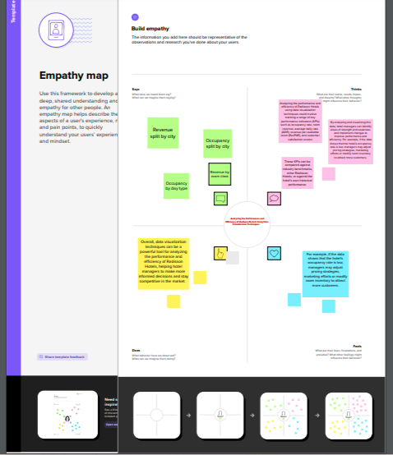

A brainstorming map, also known as a mind map or concept map, is a visual representation of ideas or concepts generated during a brainstorming session. It is a graphical tool that organizes thoughts and ideas in a hierarchical or interconnected manner, allowing for easy visualization and exploration of relationships between different ideas.

A brainstorming map typically starts with a central idea or topic in the center of the map, and related ideas or concepts are then branched out from the central idea using lines or arrows. These branches can further extend into sub-branches, creating a web of interconnected ideas. Each idea or concept can be represented by a word, phrase, or image, and the map can include colors, symbols, or other visual elements to enhance understanding and recall.

Brainstorming maps are useful for capturing and organizing ideas during brainstorming sessions, problem-solving exercises, or creative thinking activities. They can help individuals or teams to generate, organize, and expand upon ideas in a visual and non-linear way, allowing for free-flowing and flexible thinking. Brainstorming maps can be created on paper or using digital tools, and can be easily modified, expanded, or shared with others for collaborative brainstorming sessions.

Top of Form

Bottom of Form

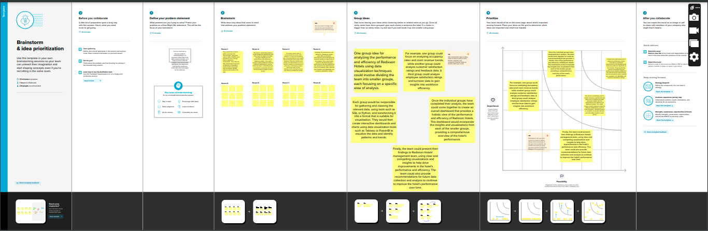

**RESULT**

* Identification of areas of inefficiency: By analyzing data such as occupancy rates, room revenue trends, and employee turnover rates, the team may identify areas of inefficiency within the hotel. For example, they may find that certain types of rooms are consistently underutilized, or that particular shifts have higher rates of employee turnover. These insights can then be used to make operational improvements and increase efficiency.
* Insights into customer satisfaction: By analyzing customer feedback data and satisfaction ratings, the team may gain insights into areas where the hotel is excelling and areas where improvement is needed. For example, they may find that customers consistently rate the hotel highly for cleanliness and comfort, but have lower ratings for the quality of the food or the responsiveness of the staff. These insights can then be used to make targeted improvements to enhance customer satisfaction.
* Identification of areas of inefficiency: By analyzing data such as occupancy rates, room revenue trends, and employee turnover rates, the team may identify areas of inefficiency within the hotel. For example, they may find that certain types of rooms are consistently underutilized, or that particular shifts have higher rates of employee turnover. These insights can then be used to make operational improvements and increase efficiency.
* Insights into customer satisfaction: By analyzing customer feedback data and satisfaction ratings, the team may gain insights into areas where the hotel is excelling and areas where improvement is needed. For example, they may find that customers consistently rate the hotel highly for cleanliness and comfort, but have lower ratings for the quality of the food or the responsiveness of the staff. These insights can then be used to make targeted improvements to enhance customer satisfaction.
* Opportunities for revenue growth: By analyzing room revenue trends, the team may identify opportunities to increase revenue. For example, they may find that certain types of rooms or amenities are consistently in high demand and can be priced accordingly, or that there are opportunities to upsell customers on additional services or amenities.
* Recommendations for future data analysis: Based on the insights gained from the data analysis, the team may make recommendations for future data collection and analysis. For example, they may recommend collecting more detailed data on employee satisfaction or customer preferences in order to gain deeper insights into these areas and drive further improvements.

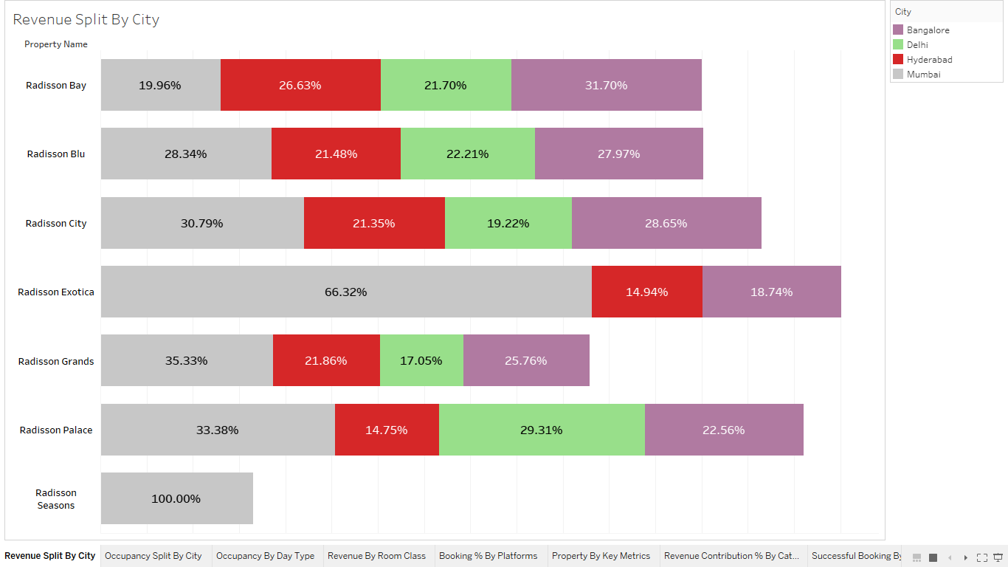

­­­­­

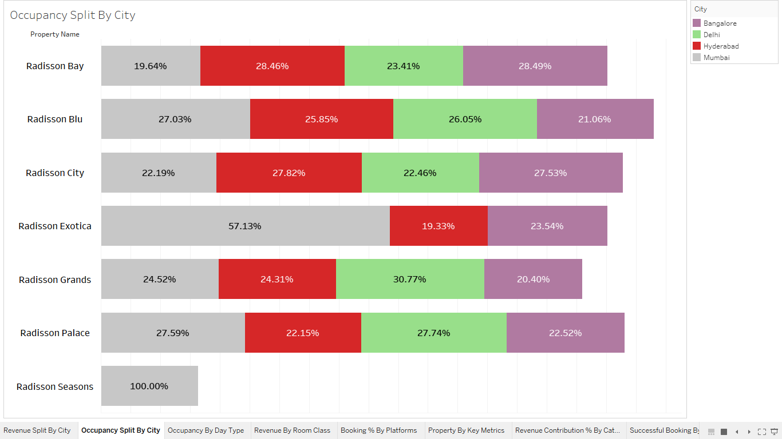

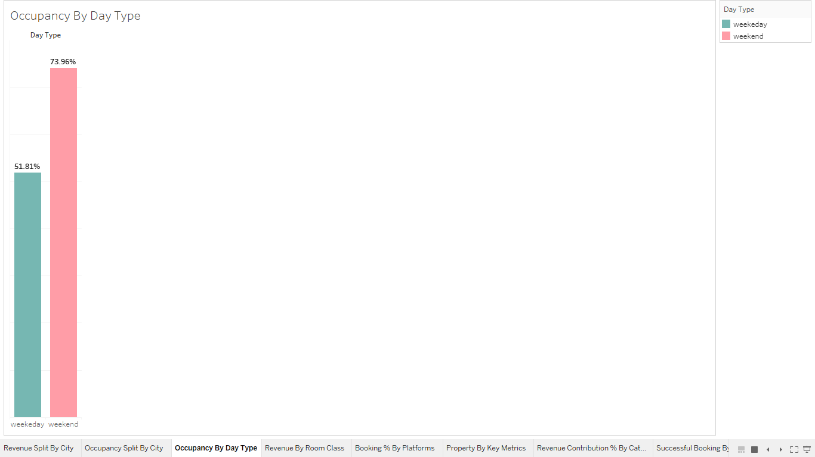

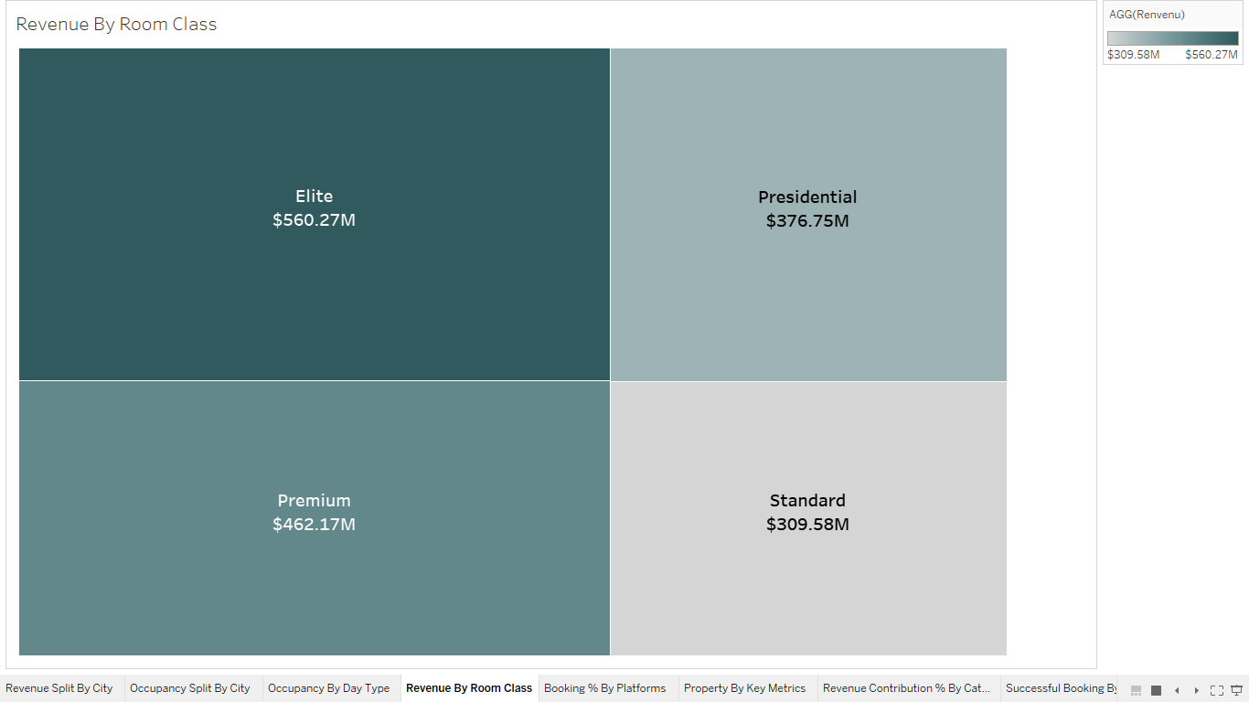

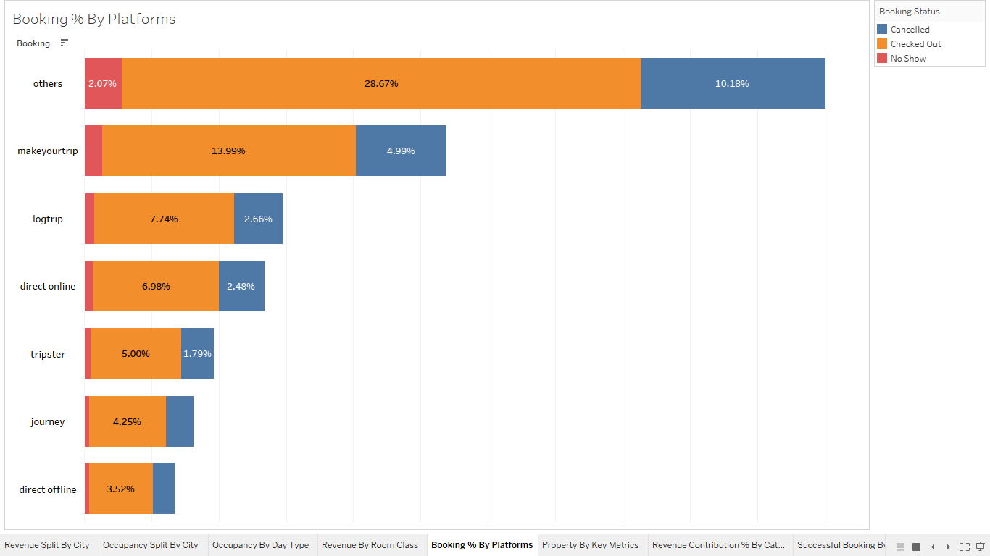

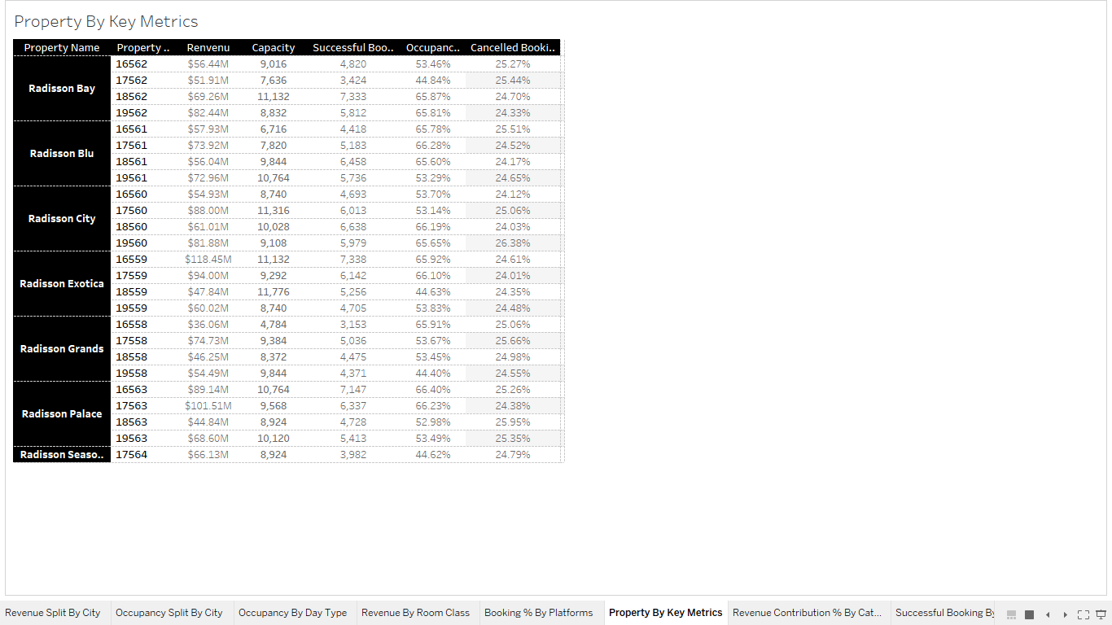

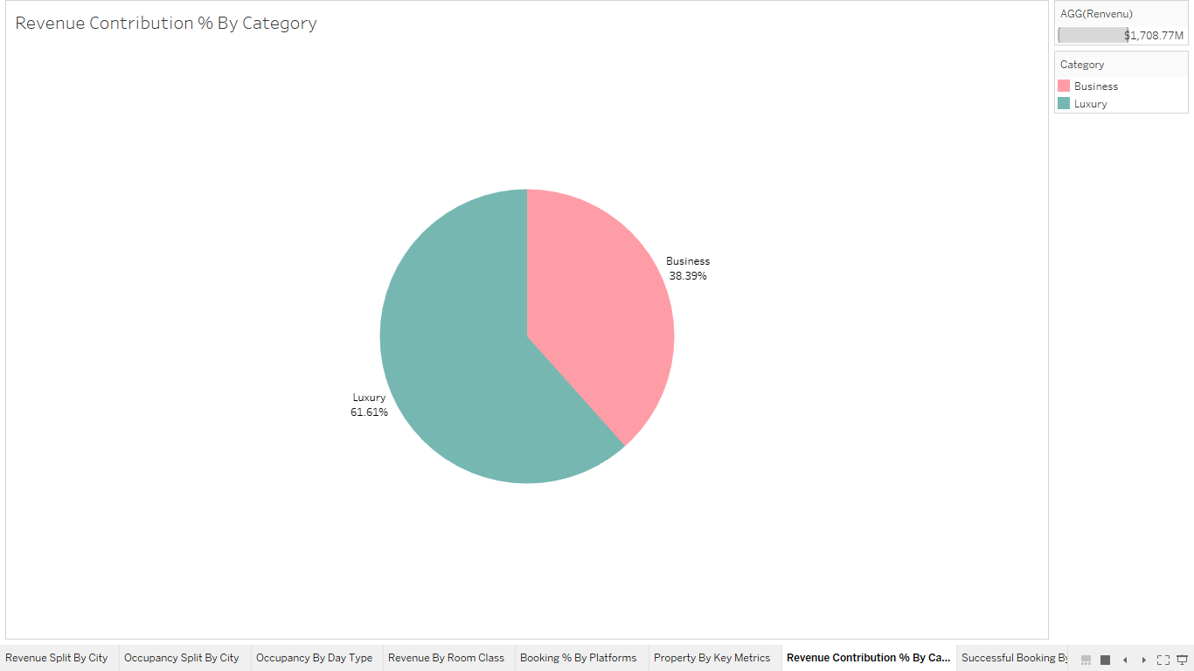

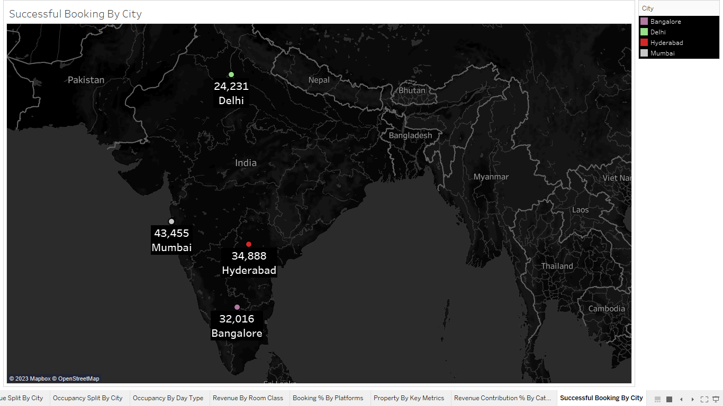

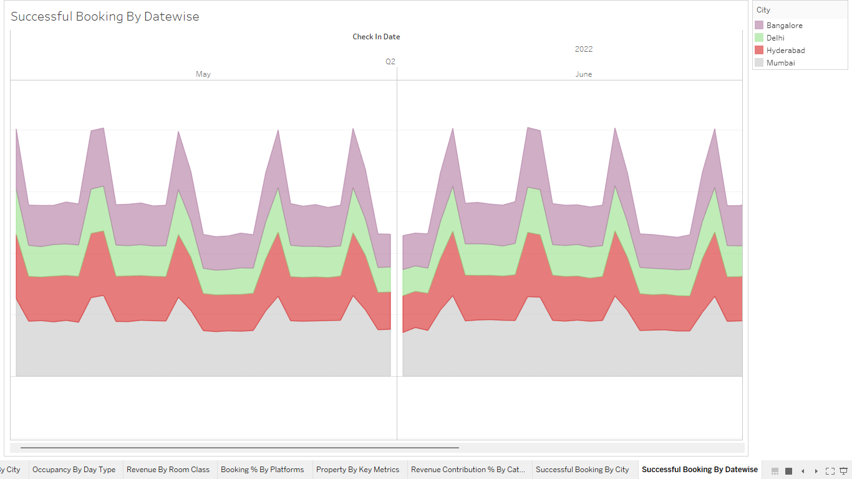

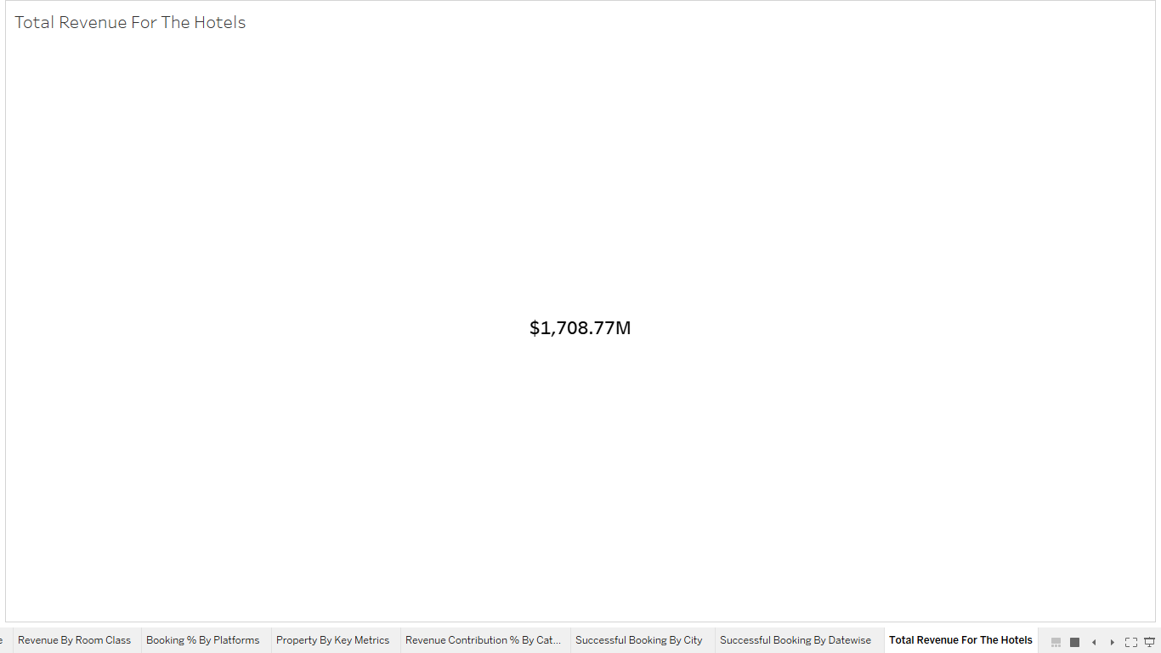

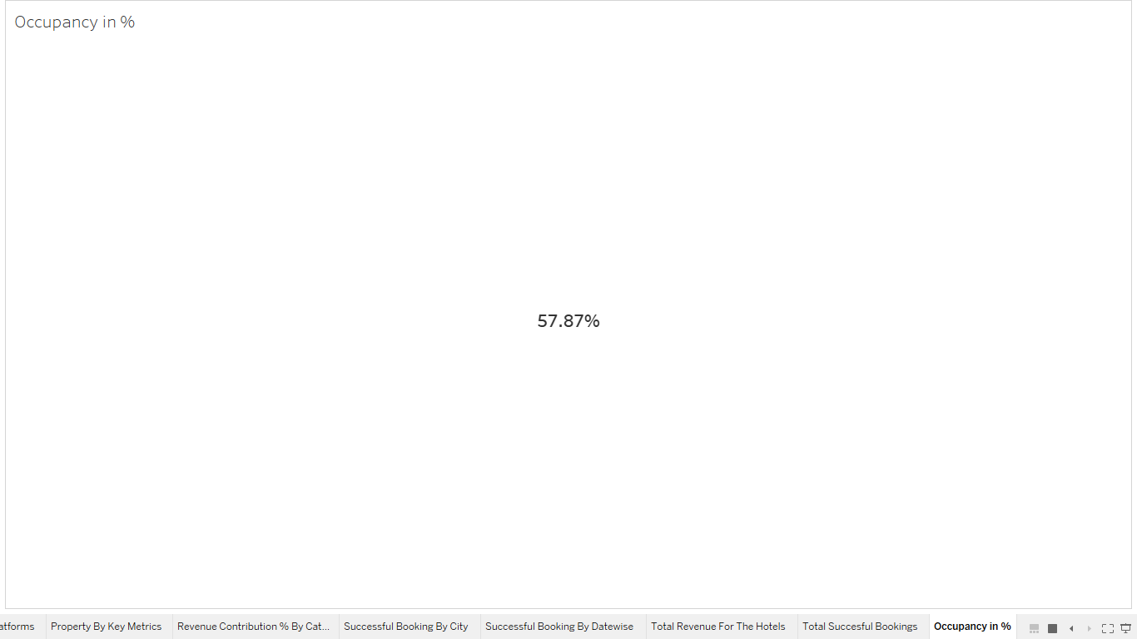

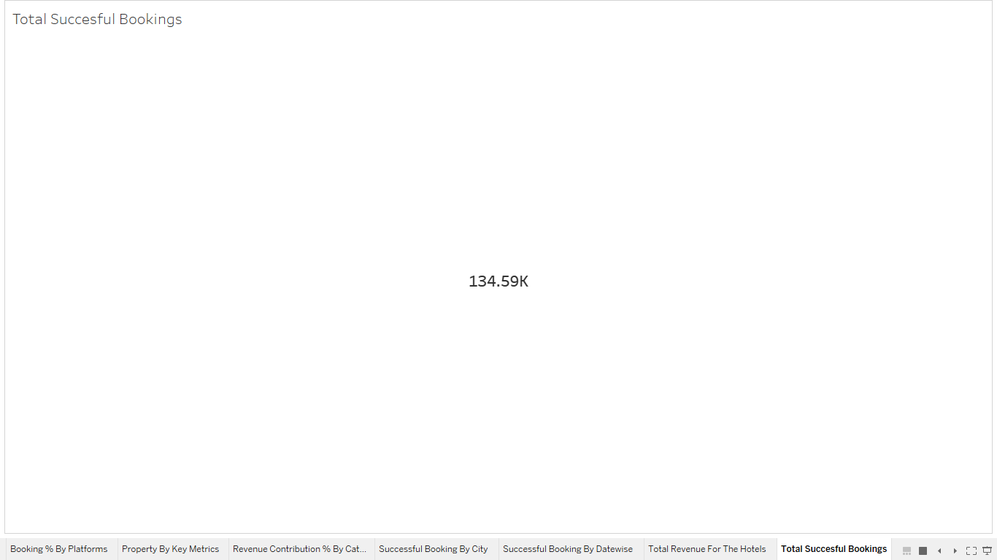

**DASHBORD For RADISSION HOSPITALATY ANALYSIS**

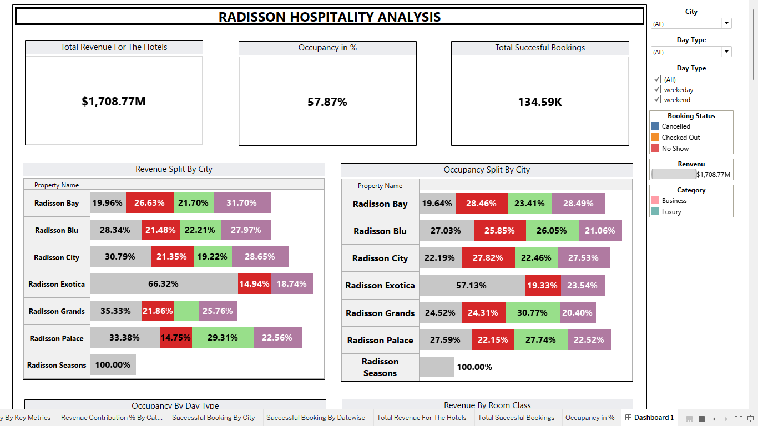

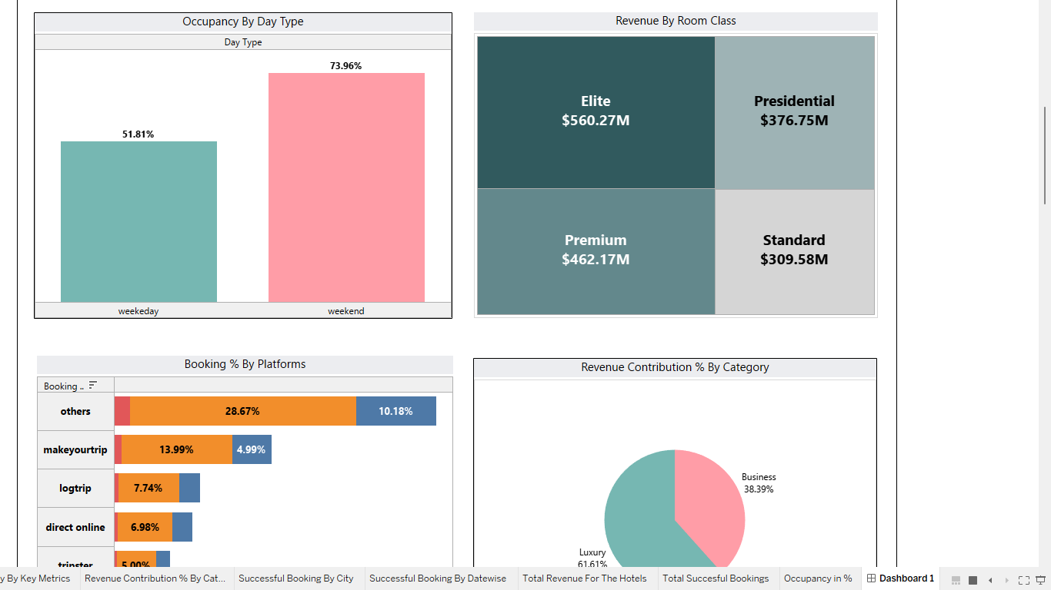

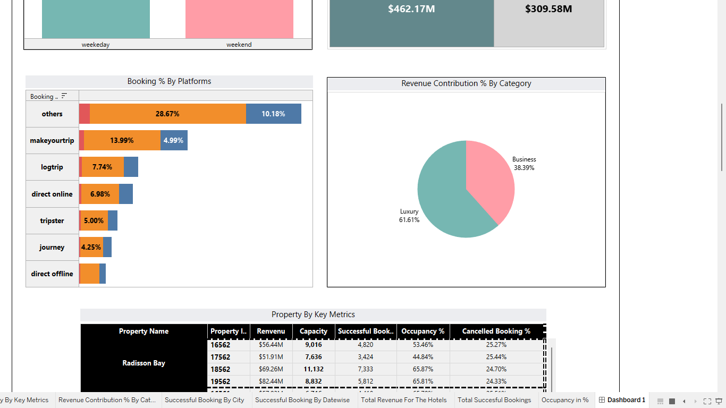

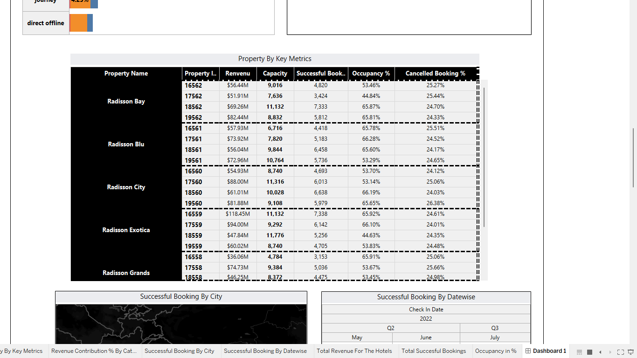

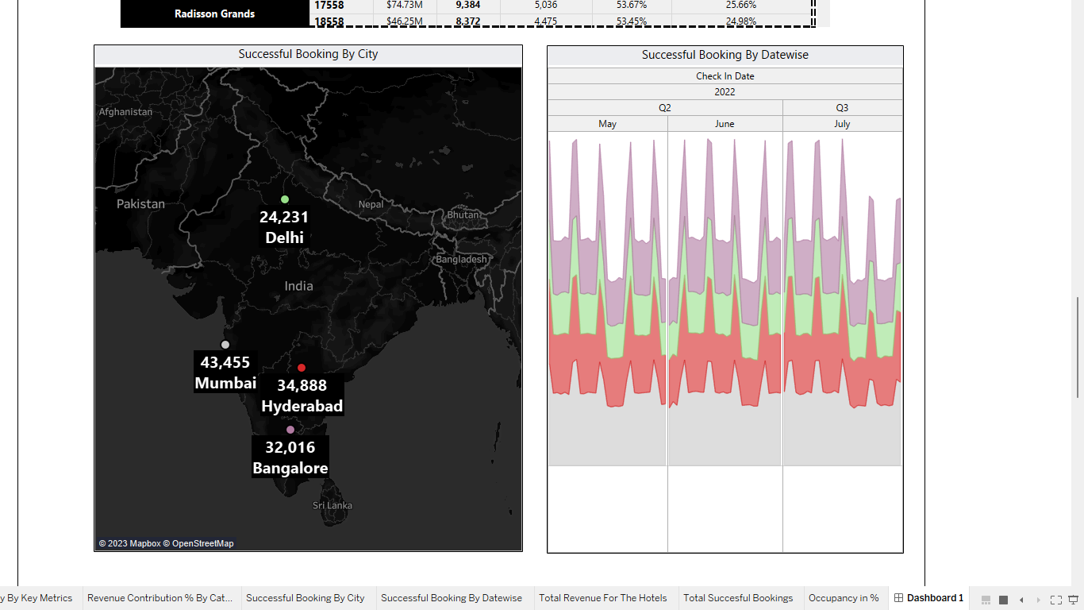

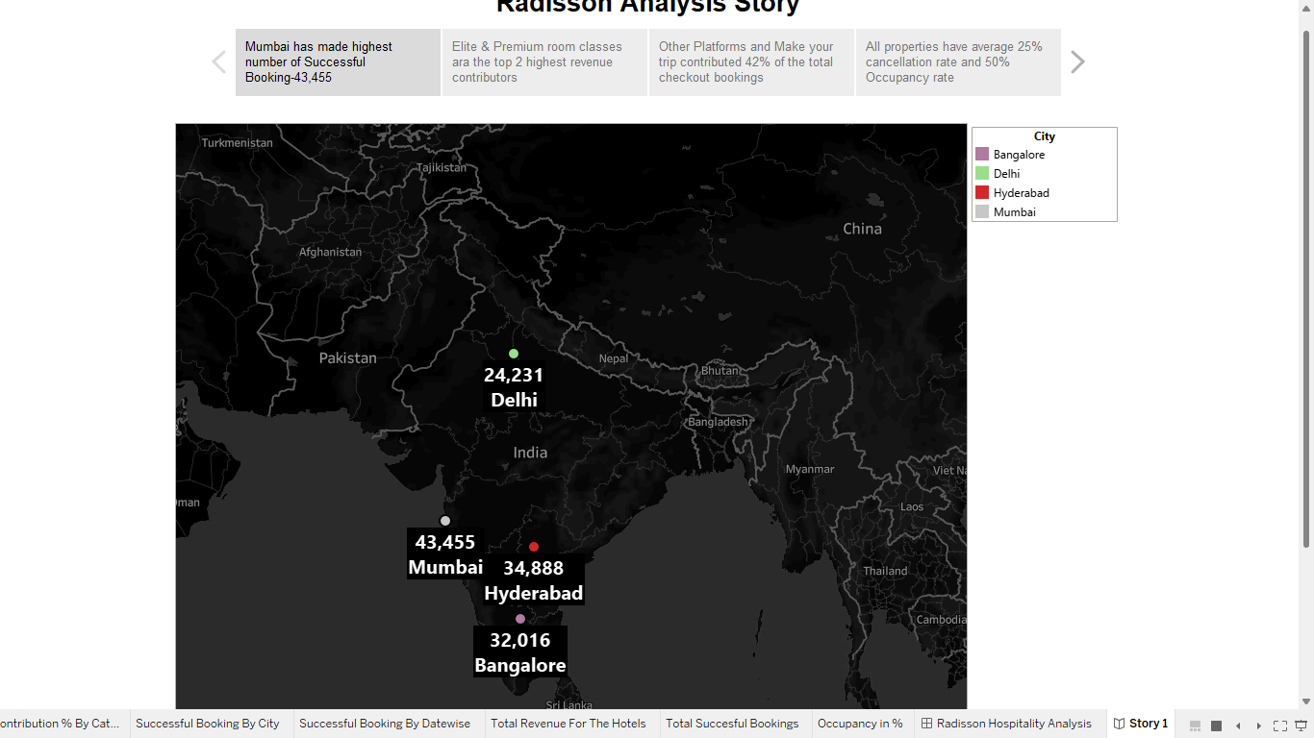

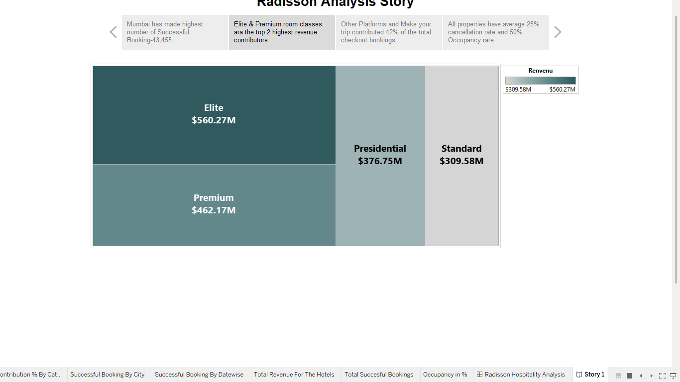

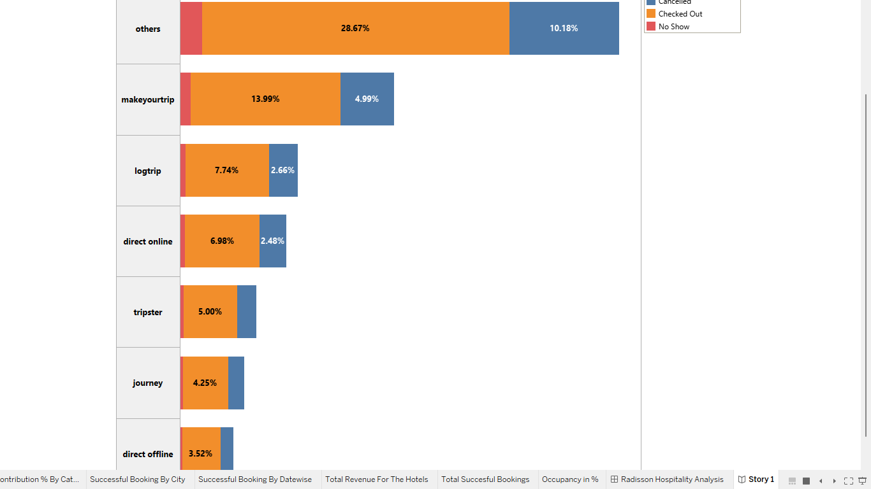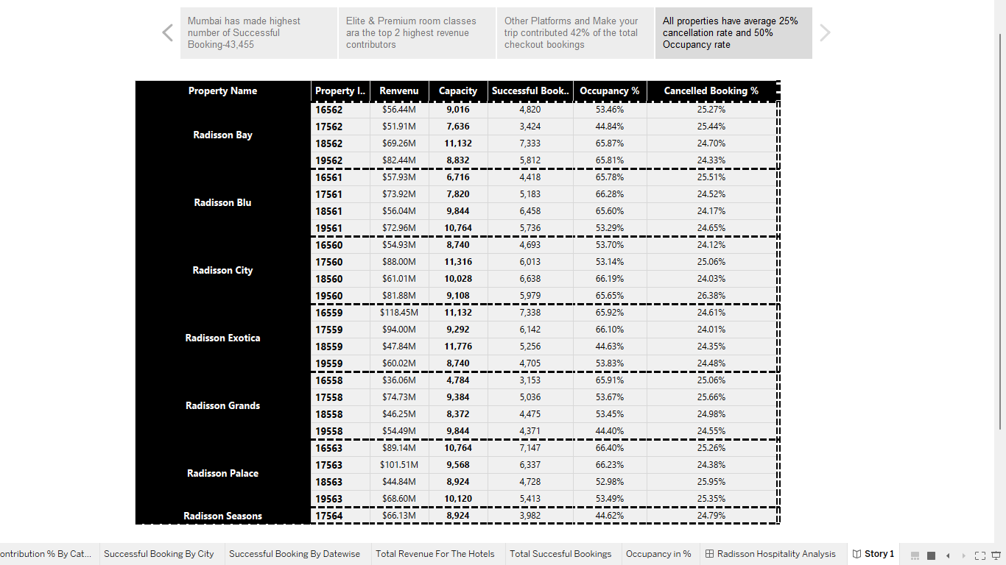

**Advantages of Analyzing the Performance and Efficiency of Radisson Hotels Using Data Visualization Techniques**:

1. Improved Decision Making: Data visualization techniques help decision-makers to gain insights into the performance and efficiency of the hotel. This allows them to make informed decisions that are backed up by data.
2. Increased Efficiency: Analyzing data on hotel operations and customer feedback can help to identify areas where the hotel is underperforming or where improvements can be made. This can lead to increased efficiency and reduced costs.
3. Enhanced Customer Experience: By analyzing customer feedback and preferences, the hotel can identify areas where it needs to improve to enhance the customer experience. This can lead to increased customer loyalty and positive reviews, which can attract more customers to the hotel.
4. Competitive Advantage: By using data visualization techniques to gain insights into the hotel's performance and efficiency, the hotel can gain a competitive advantage over its rivals. This can lead to increased revenue and profitability.

**Disadvantages of Analyzing the Performance and Efficiency of Radisson Hotels Using Data Visualization Techniques:**

1. Data Quality: The accuracy and reliability of the data used for analysis can impact the validity of the results. If the data is incomplete or inaccurate, the insights gained may be flawed.
2. Cost: Analyzing data using visualization techniques can be expensive, especially if specialized tools and software are required. This can be a barrier for smaller hotels with limited budgets.
3. Time-Consuming: Analyzing data using visualization techniques can be a time-consuming process, especially if the data sets are large and complex. This can be a challenge for hotels that have limited resources and need to make decisions quickly.
4. Expertise: Analyzing data using visualization techniques requires specialized skills and knowledge. Hotels may need to hire external experts or invest in training for their staff to carry out the analysis effectively.
5. **Timeline:**

**The timeline for this project will depend on the availability of data and the complexity of the analysis. A rough estimate for the timeline is as follows:**

* Data Collection: 2-3 weeks
* Data Cleaning and Processing: 1-2 weeks
* Data Analysis: 2-4 week
* Data Visualization: 1-2 weeks
* Interpretation of Results and Report Writing: 1-2 weeks

1. **Conclusion:**
2. In conclusion, this project aims to analyze the performance and efficiency of Radisson Hotels using data visualization techniques. By collecting, cleaning, analyzing, and visualizing data related to key performance indicators and operational metrics, we expect to gain insights that can help Radisson Hotels make informed decisions to improve their performance and efficiency in the highly competitive hospitality industry. The deliverables from this project will include a comprehensive report and data visualizations that can be used by Radisson Hotels to drive strategic decision-making and achieve their business objectives.

**APPENDIX**

**Source Code**

